Title: A Heuristic Algorithm for Quantifying Point-Pattern Disorder with Applications to Differentiation of Planned and Natural Point Collections

**Authors:** S. Jones1, H.G. Momm1*, R. ElKadiri1

**Affiliations:**

1Department of Geosciences, Middle Tennessee State University, Murfreesboro, Tennessee

*E-mail: Henrique.Momm@mtsu.edu

**Abstract:**

In any dataset the relationships between data points often contain information beyond the simple values associated with any single data point. For geographic data this idea is most commonly demonstrated with the concept of spatial autocorrelation, but many other techniques have been developed to quantify different conceptualizations of self-interaction and patterns within spatial data. We propose a new metric and related algorithm that describes the visual spatial disorder of geographic point sets, the “Index of Disorder”. The IoD was applied to multiple synthetic and three natural datasets and was shown to be able to differentiate between areas of high spatial disorder (randomly placed points) and low spatial disorder (e.g., grids and other repeating patterns). Because the IoD is a quantitative metric, it can be used either as an aid for identifying areas of unusually high or low spatial disorder, or as enrichment for machine learning classification algorithms.

**One Sentence Summary:**

The spatial disorder of a given point of data can be quantified by comparing the relative positions of that point’s neighbors to the relative positions of its neighbors’ neighbors.

**Introduction**

XX

**Related Work**

XX

**Methods**

XX

**Results**

XX

**Discussion**

XX

**Conclusion**

XX

**Tables and Figures**

Table 1. Sensitivity test for Study Area 1 (Rowell’s Apple House near Crab Orchard, TN) with an IoD threshold of 0.8. Optimal results are obtained when a neighborhood radius is selected that is similar to the scale of the expected pattern, and a $k_{m}$ is selected that is similar to the scale of the expected pattern deviations. An excessively small $k_{m}$ results in oversensitivity to pattern noise and thus ordered points as classified as disordered, while an excessively large $k_{m}$ results in underdiscrimination against disorder and thus disordered points are classified as ordered.





Figure 1. Visualization of the neighborhood comparison portion of the IoD algorithm.



Figure 2. An example of a sigmoidal scoring function, $s= \frac{d^{n}}{{k_{m}}^{n}+ d^{n}}$, where d is the point-pair deviation, n is the function cooperativity and $k_{m}$ is the deviation midpoint. An n of 1 will create a hyperbolic function, while values greater than 1 will make the function increasingly sigmoidal. The value of $k_{m}$ is the value of d at which $s=0.5$; this is represented by the dashed green lines. This equation is commonly used in biochemical investigations to model enzyme kinetics, where it is known as the Hill equation and $k_{m}$ is known as the Michaelis-Menten constant.

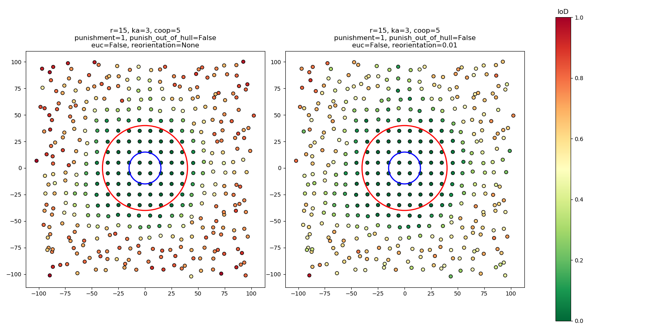

Figure 3. Results from applying two versions of the IoD algorithm without and with realignment (left and right respectively) to a square grid. The pattern is perturbed with random noise that increases in strength as a function of distance beyond the red circle, and the blue circle represents the neighborhood size.

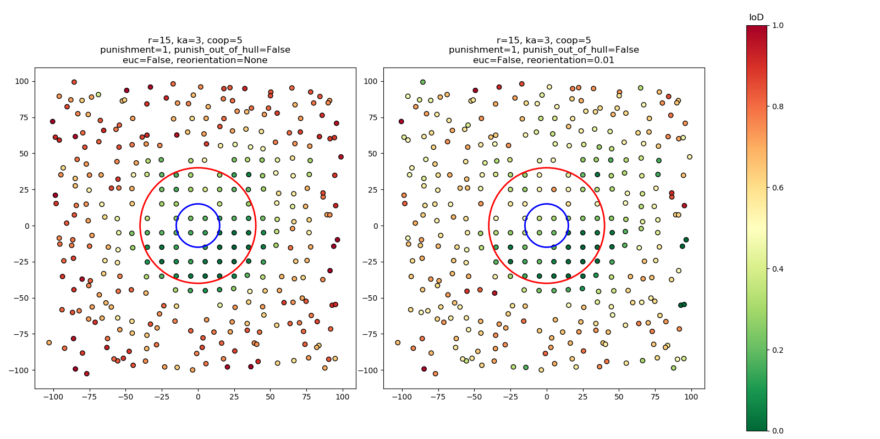

Figure 4. Results from applying two versions of the IoD algorithm without and with realignment (left and right respectively) to a square grid with 10% of the points randomly removed. The pattern is perturbed with random noise that increases in strength as a function of distance beyond the red circle, and the blue circle represents the neighborhood size.

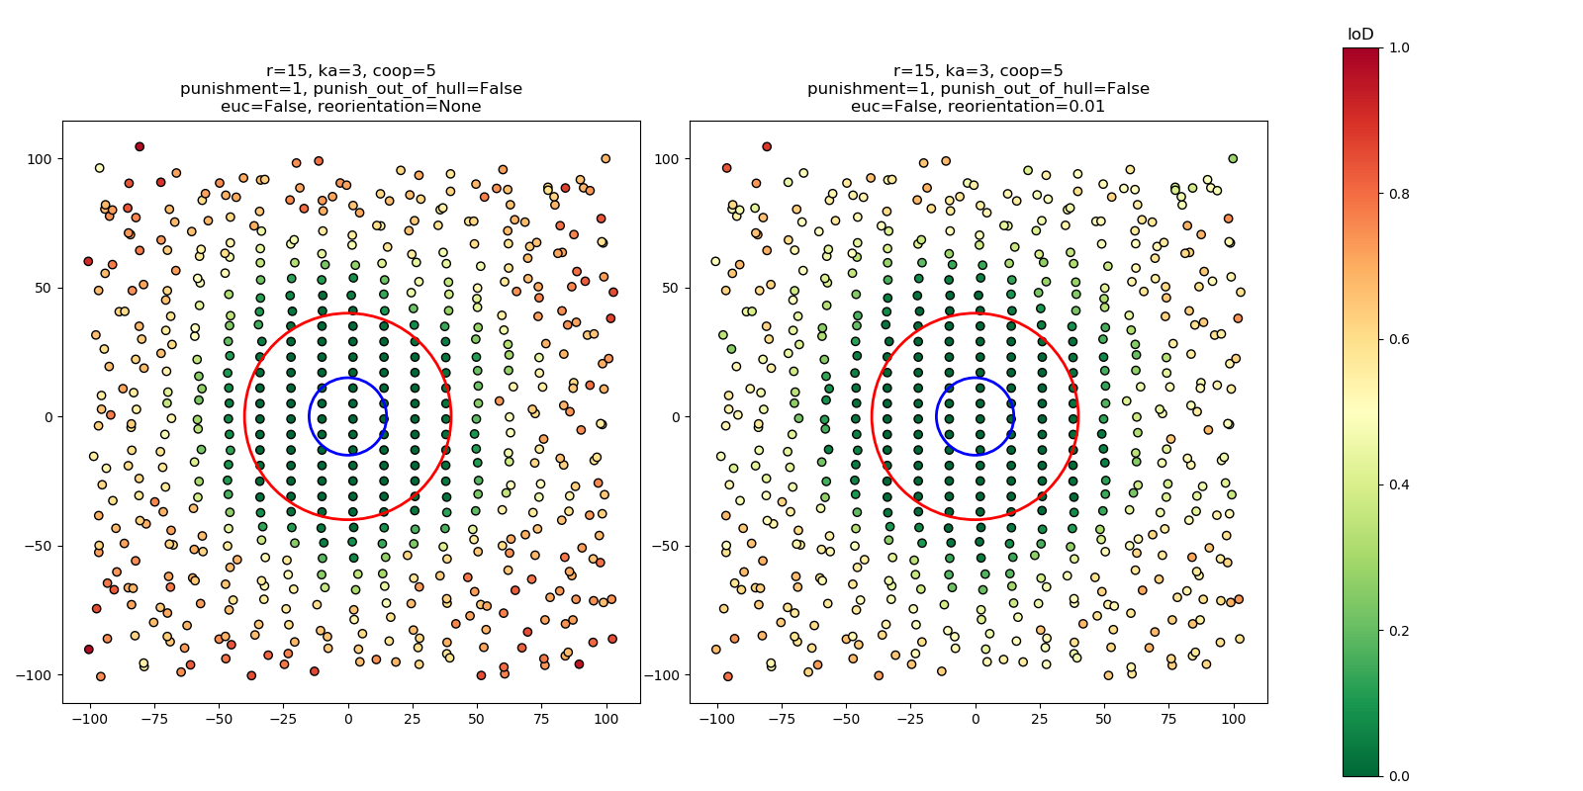

Figure 5. Results from applying two versions of the IoD algorithm without and with realignment (left and right respectively) to a rectangular grid. The pattern is perturbed with random noise that increases in strength as a function of distance beyond the red circle, and the blue circle represents the neighborhood size.

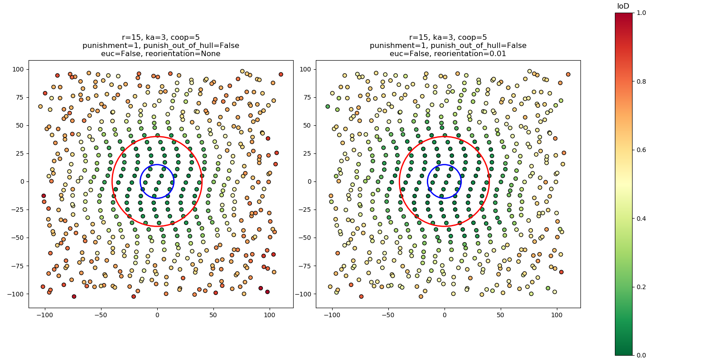

Figure 6. Results from applying two versions of the IoD algorithm without and with realignment (left and right respectively) to a rectangular grid modified with a sinusoidal signal. The pattern is perturbed with random noise that increases in strength as a function of distance beyond the red circle, and the blue circle represents the neighborhood size.

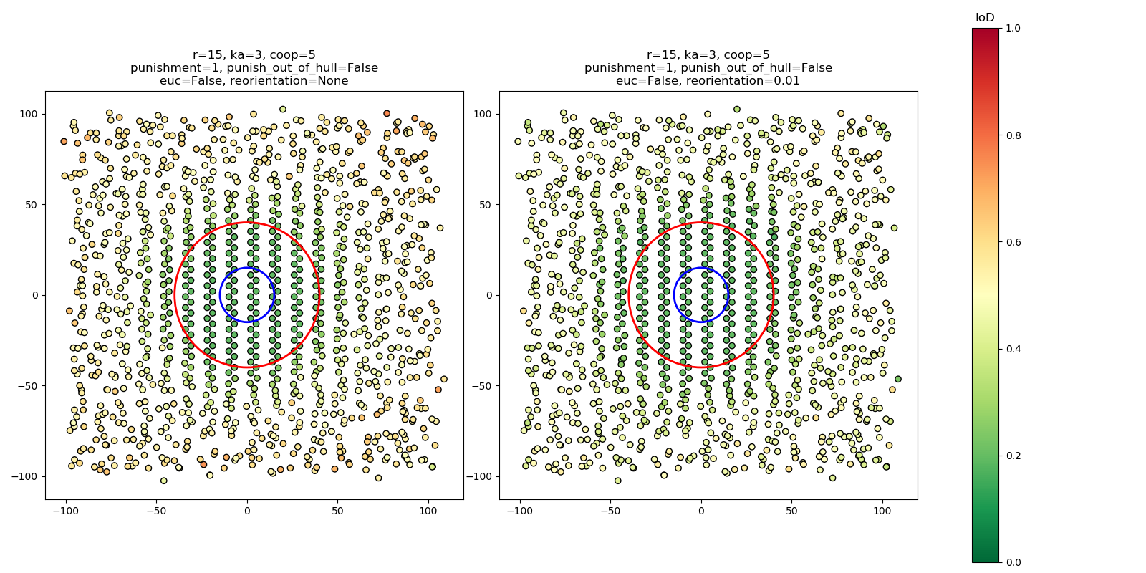

Figure 7. Results from applying two versions of the IoD algorithm without and with realignment (left and right respectively) to a pattern formed by overlapping two offset rectangular grids. The pattern is perturbed with random noise that increases in strength as a function of distance beyond the red circle, and the blue circle represents the neighborhood size.

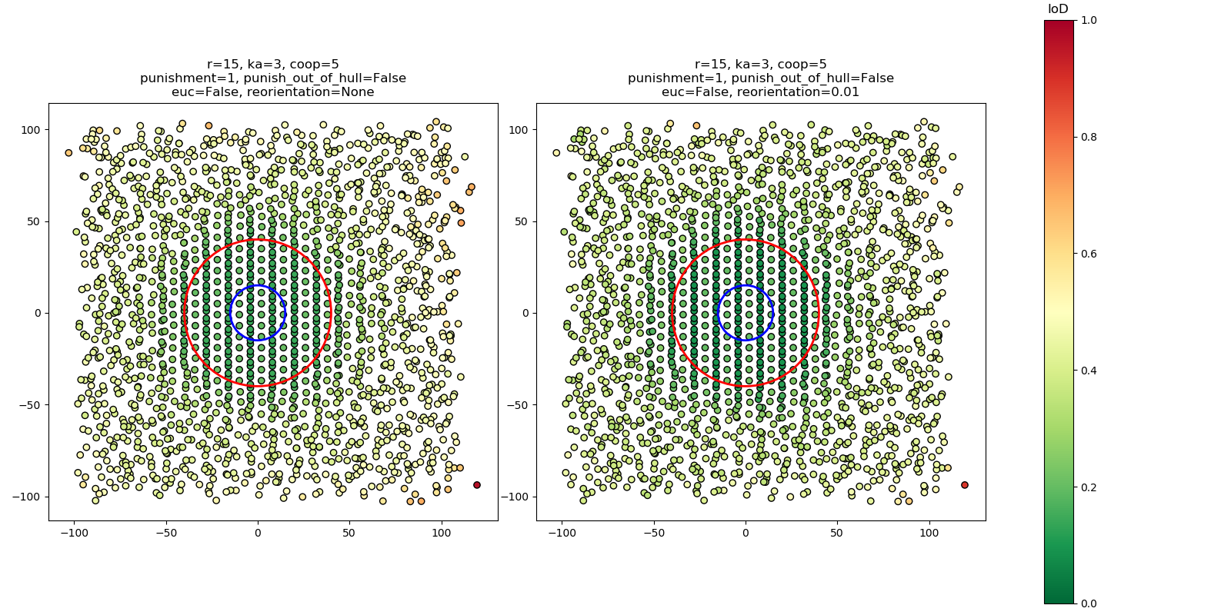

Figure 8. Results from applying two versions of the IoD algorithm without and with realignment (left and right respectively) to a pattern formed by overlapping three offset rectangular grids. The pattern is perturbed with random noise that increases in strength as a function of distance beyond the red circle, and the blue circle represents the neighborhood size.

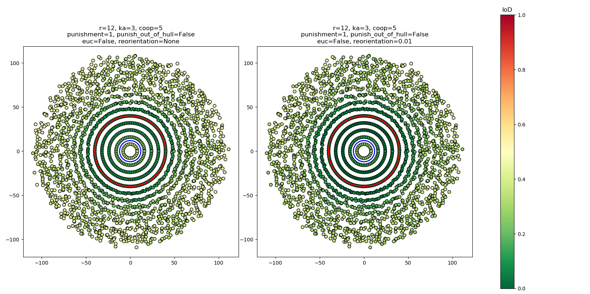

Figure 9. Results from applying two versions of the IoD algorithm without and with realignment (left and right respectively) to a pattern formed by overlaying concentric circles with equal linear point densities. The pattern is perturbed with random noise that increases in strength as a function of distance beyond the red circle, and the blue circle represents the neighborhood size.

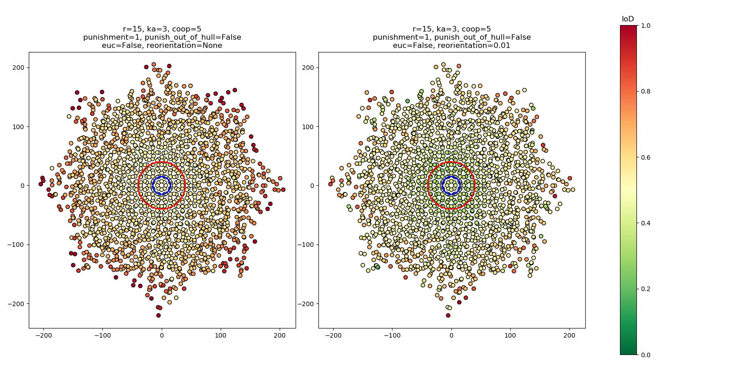

Figure 10. Results from applying two versions of the IoD algorithm without and with realignment (left and right respectively) to a pattern formed by overlapping a square grid with a copy of the same grid rotated 45 degrees. The pattern is perturbed with random noise that increases in strength as a function of distance beyond the red circle, and the blue circle represents the neighborhood size.

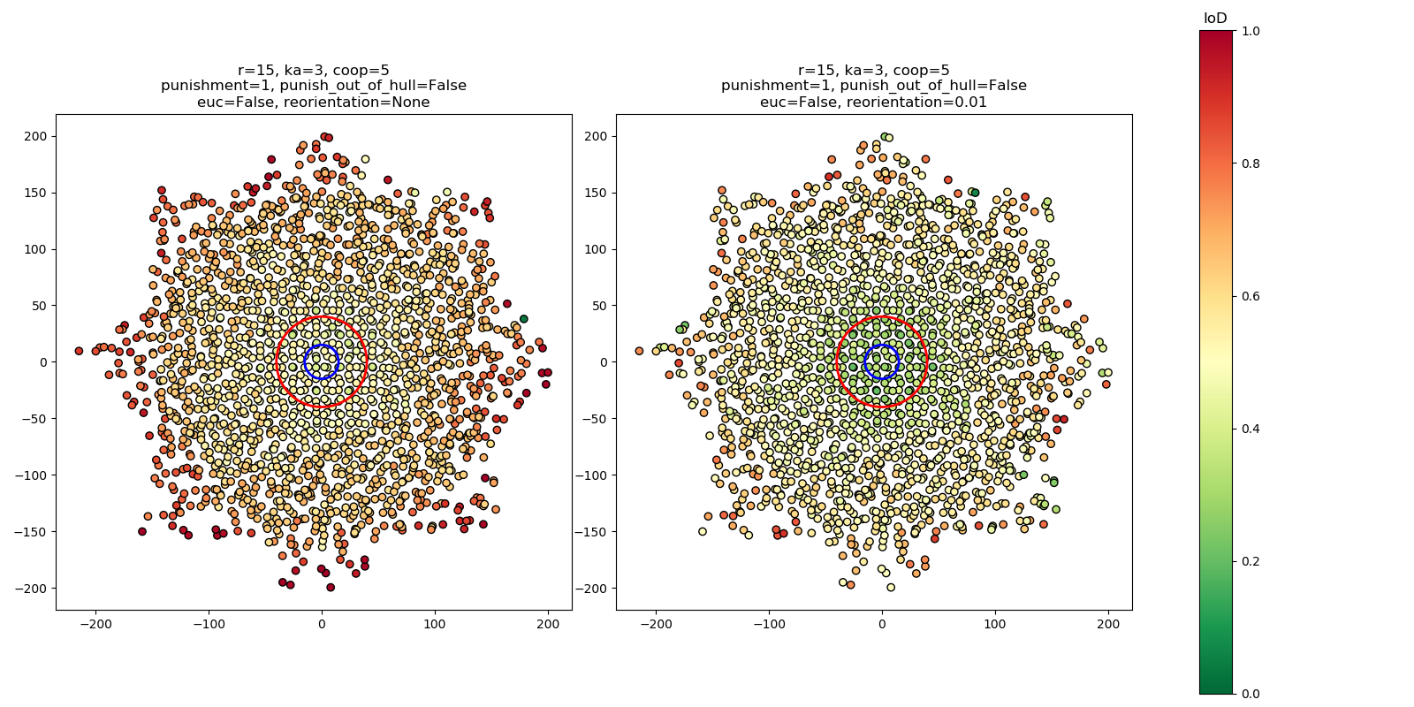

Figure 11. Results from applying two versions of the IoD algorithm without and with realignment (left and right respectively) to a pattern formed by overlapping a square grid with a copy of the same grid rotated 45 degrees and translated slightly. The pattern is perturbed with random noise that increases in strength as a function of distance beyond the red circle, and the blue circle represents the neighborhood size.

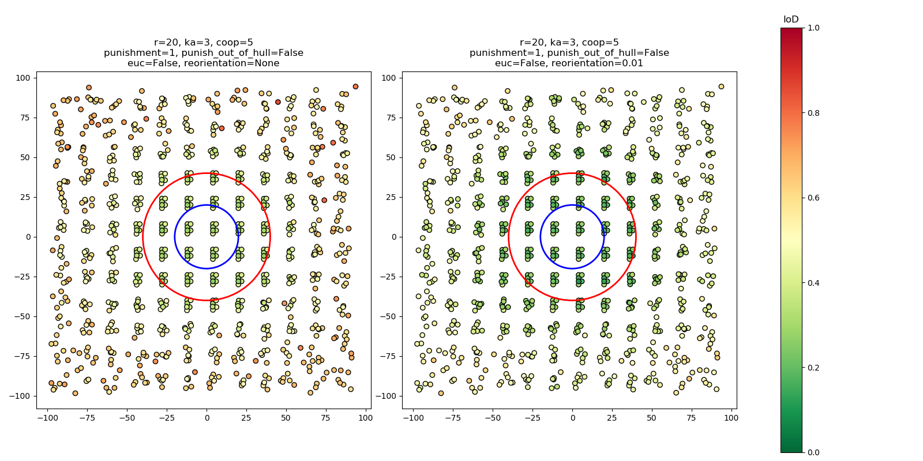

Figure 12. Results from applying two versions of the IoD algorithm without and with realignment (left and right respectively) to a pattern that consists of a repeating “stamped” unit. The pattern is perturbed with random noise that increases in strength as a function of distance beyond the red circle, and the blue circle represents the neighborhood size.

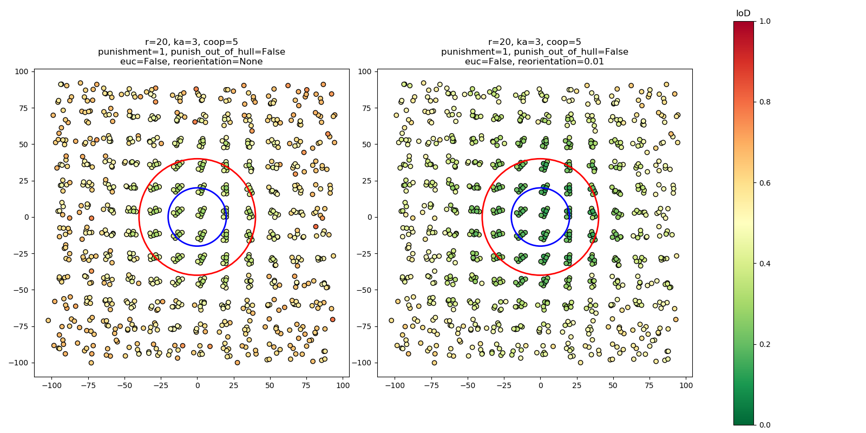

Figure 13. Results from applying two versions of the IoD algorithm without and with realignment (left and right respectively) to a pattern that consists of a repeating “stamped” unit that is continuously rotated. The pattern is perturbed with random noise that increases in strength as a function of distance beyond the red circle, and the blue circle represents the neighborhood size.

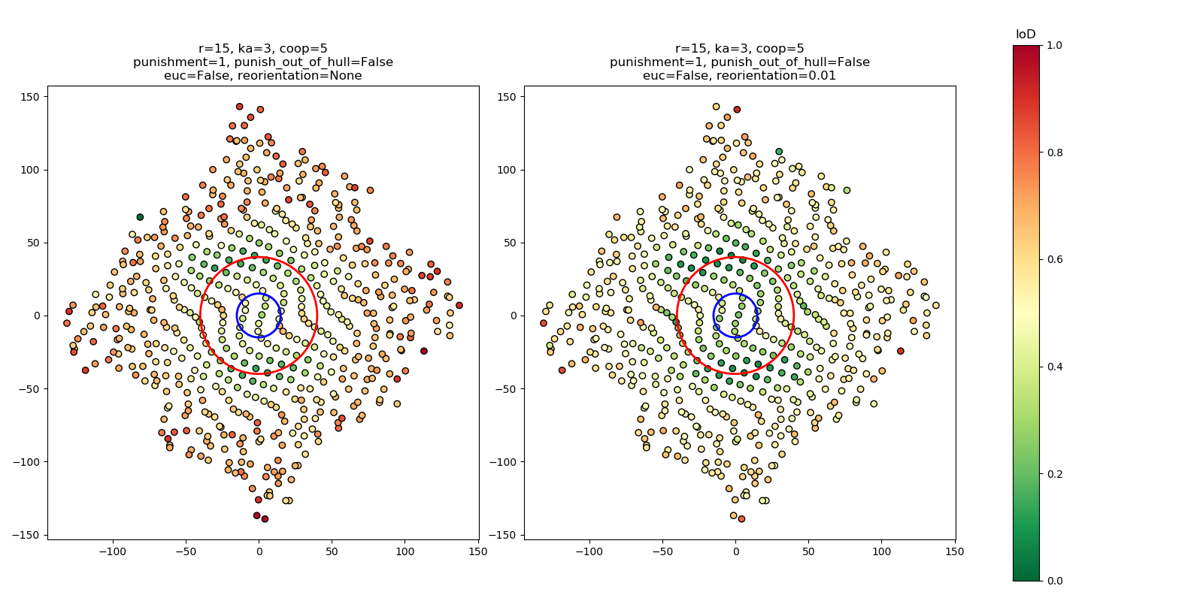

Figure 14. Results from applying two versions of the IoD algorithm without and with realignment (left and right respectively) to a rectangular grid that has been modified by two sinusoidal signals with different directionality. The pattern is perturbed with random noise that increases in strength as a function of distance beyond the red circle, and the blue circle represents the neighborhood size.



Figure 15. Results from applying the IoD to trees extracted from a DHM of Rowell’s Apple House, an orchard near Crab Orchard, TN.



Figure 16. Results from applying the IoD to trees extracted from a DHM of a mixed planted and natural forest stand near Mooresville, NC.

All Figures and Tables should be cited in order, including those in the Supplementary Material (which should be cited as, for example, “Fig. S1”, and “Table S1”). You may include line or page breaks if you would like to place the figures within the text near where they are referenced. Please do not place figures in text boxes.

Figure 17. A map of building centroids in metropolitan Nashville. Centroids were evaluated with the IoD algorithm with a radius of 100 meters, a km of 10m and an n of 5.

References should be cited in parentheses with an italic number (*1*). Multiple reference citations are separated by commas *(2, 3)* or if a series, dashes *(4-6)*. References are cited in order by where they first are called out, through the text, captions, and then the supplementary material.

Equations can be included. We do not recommend using the native Word 2007, 2008, 2010, or 2011 equation editor. This can in some cases produce less reliable MathML, the online markup language we use, which may result in display errors. Instead, use the legacy equation editor in Word (Chose Insert > Insert Object > Word Equation) or use Mathtype (recommended). If you enter equations in simple LaTeX, check that they will convert accurately (Word 2007 and higher can convert simple LaTeX equations).

References and Notes:

1. Jiang, Bin, and Junjun Yin. “Ht-Index for Quantifying the Fractal or Scaling Structure of Geographic Features.” *Annals of the Association of American Geographers*, vol. 104, no. 3, Mar. 2013, pp. 530–540., doi:10.1080/00045608.2013.834239.

**Acknowledgments:** Acknowledgments follow the references and notes but are not numbered. Acknowledgments should be gathered into a paragraph after the final numbered reference. This section should start by acknowledging non-author contributions and then should provide information under the following headings: **Funding:** include complete funding information, including grant numbers; **Author contributions:** a complete list of contributions to the paper [we encourage you to follow the [CRediT](http://docs.casrai.org/CRediT) model]; **Competing interests:** competing interests (including but not limited to patents, financial holdings, professional affiliations, advisory positions, and board memberships) of any of the authors must be listed (all authors must also fill out a separate, internal Conflict of Interest form). Where authors have no competing interests, this should also be declared (e.g., “Authors declare no competing interests.”); and **Data and materials availability:** Include a note explaining any restrictions on materials, such as materials transfer agreements. Note accession numbers to any data relating to the paper and deposited in a public database; include a brief description of the data set or model with the number. If all data are in the paper and supplementary materials include the sentence “All data is available in the main text or the supplementary materials.” All data, code, and materials used in the analysis must be available in some form to any researcher for purposes of reproducing or extending the analysis.